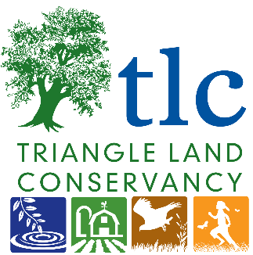

Updated 05/17/2023
Farmer applicant,
Thank you for your interest in participating in the Next Generation (NextGen) Farmer Program with Triangle Land Conservancy (TLC) at TLC’s Bailey and Sarah Williamson Farm & Nature Preserve.
Before applying, please review the complete Agricultural Concept Plan for Williamson Preserve. At the end of the Agricultural Concept Plan, there is a set of Guiding Principles, to which all participating farmers and ranchers must agree before beginning operations on site. This plan is also available on TLC’s website.
Your application will be reviewed by TLC staff and other partners to best match the applicant with the necessary resources at Williamson Preserve. Please provide as much detailed information as possible about the farm goals for your project. If you have questions or need more information during the application process, please email me at hszaro@triangleland.org.
Si necesita una copia de esta convocatoria en español, comuníquese con Heather Szaro,
Coordinadora de la Granja, a su correo electrónico hszaro@triangleland.org
Sincerely,
Heather Szaro
Farm Coordinator, Williamson Preserve
Triangle Land Conservancy ∙ P.O. Box 1848 ∙ Durham, NC 27702
919-908-8809 ∙ www.triangleland.org

Request for Farm Proposals: Williamson Preserve
CONTACT: Heather Szaro (hszaro@triangleland.org)
ISSUED: May 17, 2023
RESPONSES DUE: June 30, 2023

I. BACKGROUND
Triangle Land Conservancy (TLC) is a non-profit 501(c)3 organization that strives to create a healthier and more vibrant Triangle region by safeguarding clean water, protecting natural habitats, supporting local farms and food, and connecting people with nature through land protection and stewardship, catalyzing community action, and collaboration.
TLC owns and manages the Bailey and Sarah Williamson Preserve, a historic 450-acre farm and public nature preserve located in Wake and Johnston Counties at 4429 Mial Plantation Road, Raleigh NC (TLC has submitted a request to change the name of the road). In addition to 80 acres of farmland, TLC opened Williamson Preserve to the public with over 14 miles of walking, trail running, mountain biking, and other activities in September 2020.
TLC is seeking to integrate agricultural, natural, and recreational components, and the northern section of the property will host the most intensive agricultural use, as well as groups of visitors. Please be sure you have reviewed our Agricultural Concept Plan and more details about the property on TLC’s website.
Triangle Land Conservancy’s objectives for Williamson Preserve agricultural lands are to:
- Provide land at a reduced rate for farmers with at least 3 years of experience, and with a preference for socially disadvantaged farmers, female farmers, farmers of color and veteran farmers looking to mentor the next generations.
- Develop sustainable and regenerative production practices.
- Increase opportunities for the next generation of farmers.
- Support local and regional food systems.
- Invest in agricultural research, including a focus on conservation and environmental outcomes.
- Protect and improve pollinator health.
- Protect and improve soil and water quality in partnership with the Wake Soil and Water District, Wake County Extension, Wake County Open Space, and other Partners.
- Create an environment where farmers on the Williamson property work in collaboration with TLC and each other, both now and in the future, to reach our common goals.
Note: Current infrastructure at the Williamson Preserve may not include access to well water, fencing or dry storage.
II. SCOPE OF WORK
Triangle Land Conservancy will be opening 5-20 acres to an interested farmer in the Summer of 2023. Interested farmers and/or livestock operators should provide a full scope of work in the application below. Select applicants will then be asked to provide additional information on their business plan, project goals, experience, and long-term needs at the farm. The farmer will be provided with a 1-year trial period with TLC so that they and TLC staff can get to know one another and assess the strength of the project. If farm operations are a good fit for both parties, the farmer can renew this annual agreement, and after 2-3 years we will work together to draft a long-term user licensing agreement. TLC uses licensing agreements in place of leases with farmers at most properties, including Williamson Preserve.
III. QUALIFICATIONS
All interested parties should demonstrate their ability to perform agricultural activities and have at least 3 years of experience in their area of focus. Qualified candidates and their applications will be reviewed by TLC staff and the Farm Advisory Committee members before a grower is approved. Once approved, the farmer will need to show a business proposal or plan and be willing to sign a licensing agreement with the Triangle Land Conservancy for a minimum of 12 months.
IV. SUBMISSION OF APPLICATIONS
Interested applicants should email their applications to: Heather Szaro, Farm Coordinator, hszaro@triangleland.org, by 5:00 pm on June 30, 2023. If the applicant has a resume/CV that can be used in lieu of answering certain questions on the application, they are encouraged to submit that along with the application. To be considered, all questions must be answered fully, either via the resume and/or the application.
V. APPLICATION EVALUATION & NEXT STEPS
Applications will be reviewed as they are received by TLC’s Stewardship & Land Protection staff who may request additional information. Applicants will then be chosen to submit a business proposal. Proposals should be 2-5 pages in length and describe the agricultural intent of how the land will be used, outlining the scope of work, a desired timeline for beginning operations onsite, and a list of team members involved. Once those proposals are received and reviewed, applicants will then be interviewed by relevant TLC staff members. The Farm Advisory Committee will also review final applicants.

Bailey and Sarah Williamson Farm & Nature Preserve
NextGen Farmer & Rancher Program
2023-2024 Application

Please provide as much information as possible to best match your goals with the appropriate space, resources, and support at the Williamson Preserve. Resumes may be submitted along with this application in place of answering specific questions, but please indicate that. Supporting documentation of previous work projects or qualifications is welcome but not required in this phase.
Si necesita una copia de esta convocatoria en español, comuníquese con Heather Szaro,
Coordinadora de la Granja, a su correo electrónico hszaro@triangleland.org
A. PERSONAL INFORMATION:
Name: Click or tap here to enter text.
Preferred Pronouns: Click or tap here to enter text.
Date of Birth: Click or tap here to enter text.
Email Address: Click or tap here to enter text.
Phone Number: Click or tap here to enter text.
Mailing Address: Click or tap here to enter text.
Current Farm Address (if applicable): Click or tap here to enter text.
Farm / Project Name (if applicable): Click or tap here to enter text.

B. Farm Project Information
Have you received an agricultural, animal science, or related degree from an accredited college or university? A resume or CV can also be attached at the end of the application. If yes, please provide the following information:

  - University or College: Click or tap here to enter text.
  - Location of University or College: Click or tap here to enter text.
  - Program or Area of Study: Click or tap here to enter text.
  - Date of Program Competition: Click or tap here to enter text.
  - Additional Information (if needed):
Click or tap here to enter text.

- Have you completed a qualified farm management training program? If yes, please describe the completed farm management training program.
Click or tap here to enter text.

- Please detail any other farm training experience you would like to share (trainings, workshops, conferences, certifications, etc.)
Click or tap here to enter text.

- Have you ever worked as a volunteer, intern, or seasonal employee for a farm or ranch? If so, please provide information on that farm and your role in the operation.
Click or tap here to enter text.

- What is your experience specifically with sustainable or regenerative farming methods?
Click or tap here to enter text.

- Have you ever been a primary operator on a farm or ranch? If so, please elaborate.
Click or tap here to enter text.

- Do you currently own or lease any agricultural land? If so, please describe.
Click or tap here to enter text.

- If applicable, describe your current farming operation. Please provide as much detail as possible.
Click or tap here to enter text.

- Please provide links to a website or printed materials if available, along with social media handles and links (Twitter, Facebook, Instagram, or others). This is optional.
Click or tap here to enter text.

- Are you a part of any existing agricultural organizations, boards, volunteer groups, or networks?
Click or tap here to enter text.

- Describe the type of farm you would plan to have at the Williamson Preserve. Include descriptions of your farm or ranch management techniques and strategies:
Click or tap here to enter text.

- Part of this Program involves developing a management and site plan in collaboration with TLC. Are you willing to work with TLC to incorporate any mutually agreed upon best management practices into your plan?
Choose an item.

- Will you be farming by yourself or with a team of people? If you are farming with a team or group, please describe the arrangement:
Click or tap here to enter text.

- Will your farming operations be open to the public? Will volunteers be involved in any capacity (not required)? Please describe:
Click or tap here to enter text.

- Will your farming operation involve any training or demonstration components? If so, please describe:
Click or tap here to enter text.

- How many acres will you ideally need in year one? Click or tap here to enter text. And in year five? Click or tap here to enter text.

- What is the ideal length of time you want to farm at Williamson Preserve?

Click or tap here to enter text.

- What other facilities will you need in year one? Examples might include equipment, storage area, fencing, water, driveway access, transportation, etc. TLC cannot provide all these resources but can help to identify these needs and resources for them as the partnership progresses. Please provide as much detail as possible to help us understand your needs.
Click or tap here to enter text.

- Is there anything else you would like to share about your farm goals or vision now? If so, please describe:
Click or tap here to enter text.

- Before completing this application, please read the complete Agriculture Concept Plan for Williamson Preserve, including the Guiding Principles at the end of the Concept Plan. A reference map for Williamson Preserve is provided on the next page.

After completing the application, please sign below. A staff member from Triangle Land Conservancy will be in touch within 7 business days.
Print Name here:
Sign: Date:
Questions? Contact Heather Szaro, Farm Coordinator, hszaro@triangleland.org

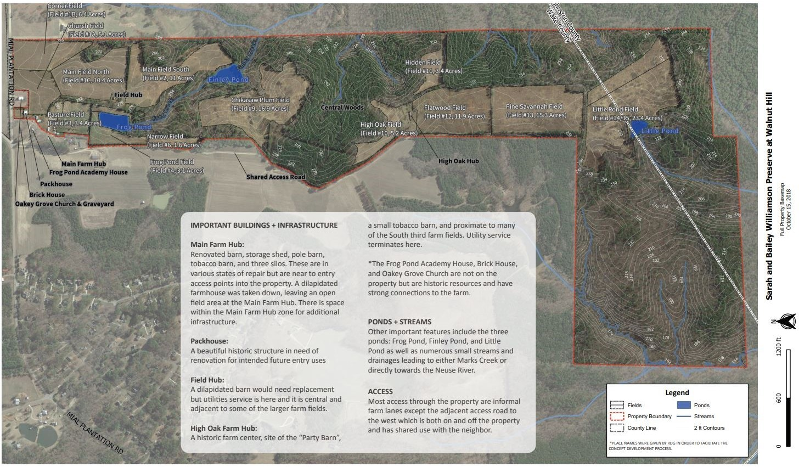
Williamson Farm & Nature Preserve Map
Figure 1: The Bailey & Sarah Williamson Preserve located at 4401 Mial Plantation Road, Raleigh, North Carolina.

